**PROJECT DESIGN PHASE-II**

**TECHNOLOGY STACK (ARCHITECTURE & STACK)**

|  |  |
| --- | --- |
| Date | 14 October 2022 |
| Team ID | PNT2022TMID15455 |
| Project Name | Early Detection of Chronic Kidney Disease Using Machine Learning |
| Maximum Marks | 2 Marks |

**Technical Architecture:**

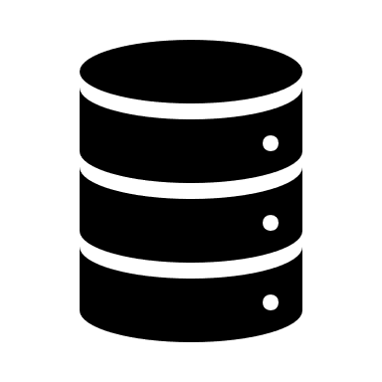  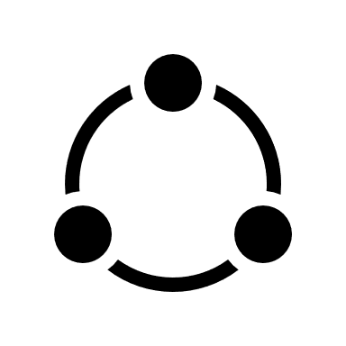 

Data Pre-processing

Feature Extraction

Data Acquisition

Collected Dataset

** **

Testing Dataset

Training Dataset

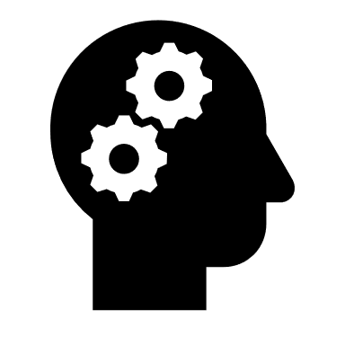 

Model Evaluation and Performance Analysis

ML Model Training

Have CKD

Don’t have CKD

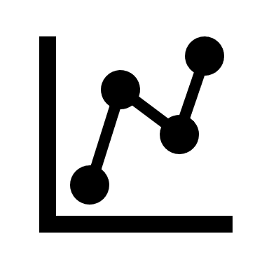

Prediction

**Table-1: Components & Technologies:**

|  |  |  |  |
| --- | --- | --- | --- |
| **S. No** | **Component** | **Description** | **Technology** |
| 1. | User Interface | User interacts by using web user interface. | HTML, CSS and Python Flask |
|  | Application Logic-1  (Login) | User can able to login if that person is already registered to the site. | HTML, CSS and Python Flask |
|  | Application Logic-2 (Register) | User needs to be registered if that person is new to the site. | HTML, CSS and Python Flask. |
|  | Application Logic-3(Reporting Form) | User needs to click on the reporting form in order to get the prediction result | Front end- HTML, CSS and Python Flask.  Back end – Query Languages, Python. |
|  | Database | Data Type-String, Numeral values. | Query Languages such as MySQL, NoSQL etc. |
|  | Cloud Database | Database Service on Cloud. | IBM DB2, IBM Cloud ant etc. |
|  | File Storage | File storage requirements. | Local Filesystem. |
|  | External API-1 | Anyone can access the details with some restrictions to the personal details of other users. | Web API. |
|  | External API-2 | Accessibility. | Aadhar API. |
|  | Machine Learning Model | Predict the result based on the training and testing dataset. | Data Recognition Model, etc. |
|  | Infrastructure (Server / Cloud) | Application Deployment on Local System. | Local System. |

**Table-2: Application Characteristics:**

| **S. No** | **Characteristics** | **Description** | **Technology** |
| --- | --- | --- | --- |
| 1. | Open-Source Frameworks | Frameworks are used for predictive data analysis, providing clear and actionable error messages. | Tensor flow, Scikit learn, Keras. |
|  | Security Implementations | OTP will be sent to the registered email id. Unauthorized users could not access the user’s details. | Email Verification. |
|  | Scalable Architecture | Scalability is improved for implementing the three-tier architecture. | Three tier architecture. |
|  | Availability | For enhancing the high availability, load balancer is needed. | Load Balancer. |
|  | Performance | The model could be able to process large number of datasets. | Load Balancer. |